COMMUNITY GARDEN PLOT MANAGER
@CREATIVITY THINK (9483175986/7019689991)

ABSTRACT:
Community Garden Plot Manager is a web-based platform designed to efficiently manage plot allocations, member activities, and harvest tracking for urban gardens, apartment communities, and schools. The system enables members to request garden plots, log activities such as planting and watering, track personal harvests, and monitor community engagement through leaderboards. Administrators can allocate plots, enforce rules, monitor activity logs, manage idle plots, and generate analytics and seasonal reports. Built with Django and Django REST Framework for backend functionality and React with recharts and axios for frontend interactivity, the platform ensures streamlined community garden management, transparency, and data-driven insights..

INTRODUCTION OF THE PROJECT:
Managing community gardens requires tracking member participation, plot allocation, and harvest outcomes. Traditional manual methods are prone to errors and inefficiencies, making it difficult to maintain fairness, monitor engagement, or optimize resource allocation. Community Garden Plot Manager addresses these challenges by providing a centralized digital system that organizes plot allocation, member activities, harvest tracking, and community analytics. The platform enhances collaboration, motivates participation, and enables administrators to make informed decisions based on real-time data..

PROJECT OBJECTIVES:

• Provide a digital platform for managing community garden plots
• Allow members to register, request, and receive plot allocations
• Enable logging of activities including planting, watering, and harvesting with photo uploads
• Track individual harvest statistics and progress
• Display community leaderboards for engagement and contributions
• Allow administrators to allocate and reallocate plots efficiently
• Provide dashboards with analytics for total harvest, active members, and plot utilization
• Facilitate community events and seasonal reporting
• Export comprehensive seasonal reports for documentation and review

PROBLEM OF THE STATEMENT:
Community gardens often struggle with equitable plot allocation, tracking member participation, and monitoring harvest outcomes. Manual systems make it difficult to enforce rules, reassign idle plots, or identify highly active members. This leads to inefficiencies, underutilized resources, and potential member dissatisfaction. Community Garden Plot Manager solves these problems by providing a structured, automated, and transparent platform for both members and administrators, improving engagement, accountability, and operational efficiency..

MOTIVATION OF THE PROJECT:
• To streamline plot allocation and membership management
• To encourage member participation through activity logging and leaderboards
• To improve transparency in garden operations
• To track individual and community harvest statistics accurately
• To provide analytics for better decision-making and resource planning
• To facilitate communication and organization of community events
• To reduce administrative workload and manual errors
• To foster an engaged and collaborative gardening community

BLOCK DAIGRAM OF PROJECT:

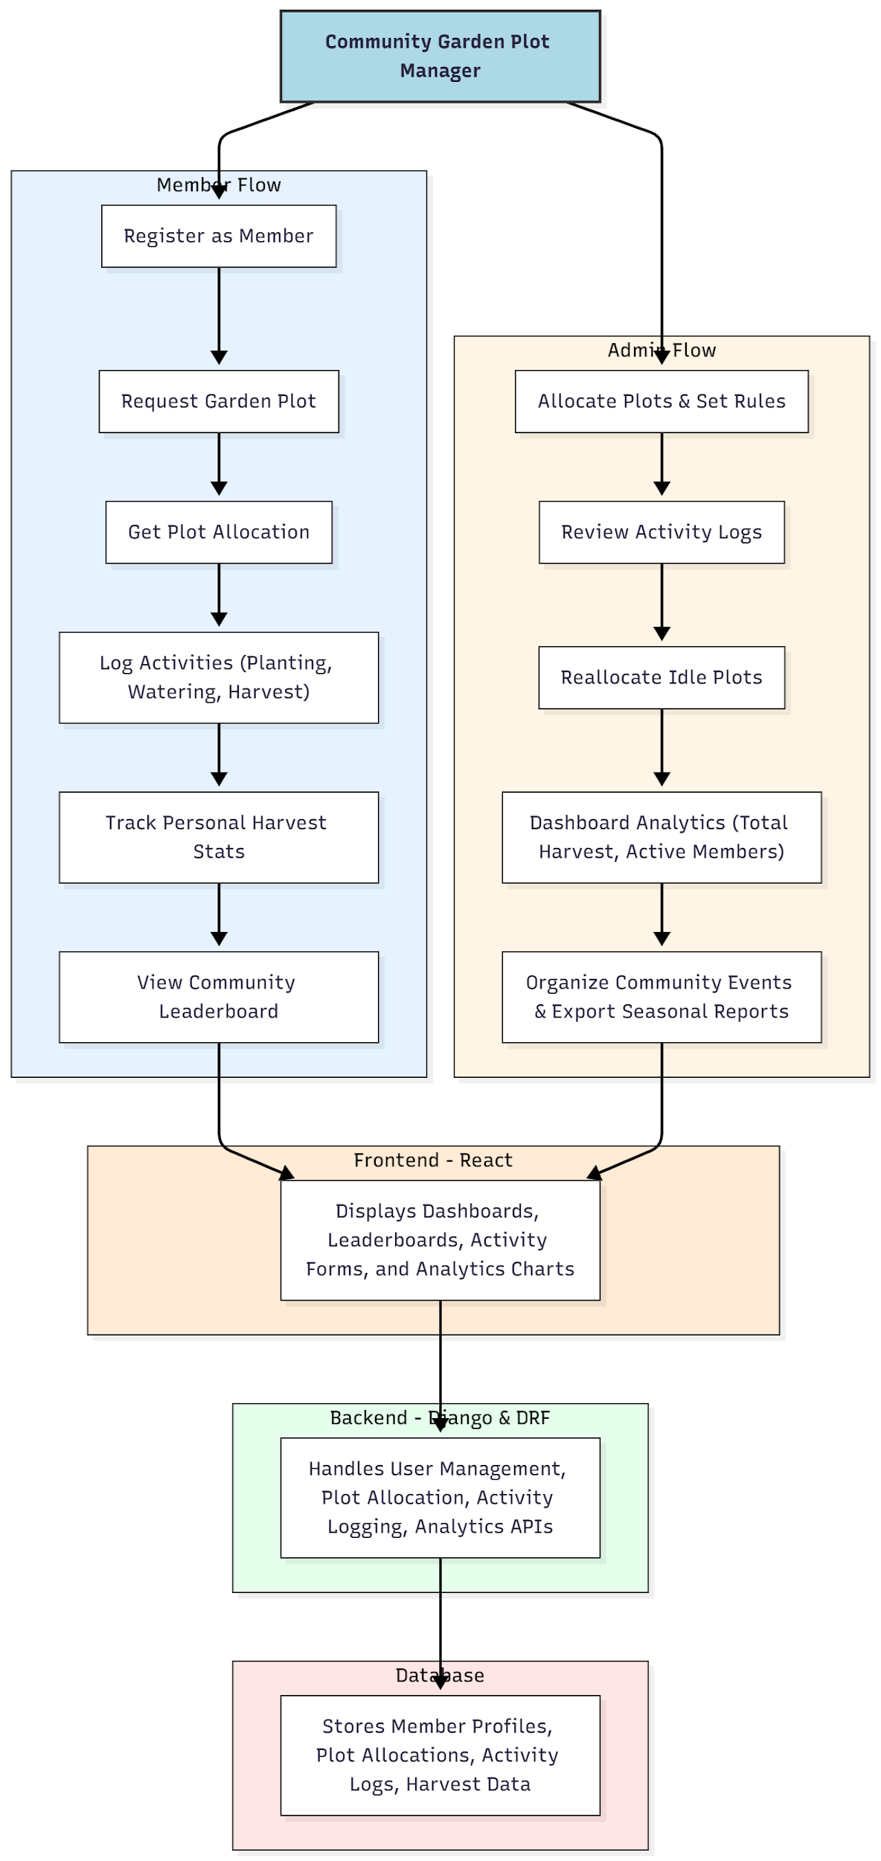

WORKING OF THE PROJECT:
Members register and request a garden plot via the portal. Once allocated, they can log all garden-related activities including planting, watering, and harvesting, attaching photos where necessary. Personal harvest stats and community leaderboards keep members motivated and informed. Administrators oversee plot allocation, review logs, reassign idle plots, and monitor community-wide analytics through dashboards. Seasonal reports summarize activity and harvest outcomes, enabling planning for future cycles. Backend services handle API requests, store member and plot data, and compute analytics, while the frontend presents interactive dashboards, forms, and charts for users and admins..

SOFTWARE REQUIREMENT:
- Backend:
  - Python 3.x
  - Django
  - Django REST Framework
  - SQLite/PostgreSQL
- Frontend:
  - Node.js and npm
  - React.js
  - Axios
- Development Tools:
  - Visual Studio Code
  - Postman (for testing APIs)
  - Git/GitHub (for version control)
- Server/Deployment (Optional):
  - Gunicorn, Nginx, or Heroku/AWS for hosting

ADVANTAGES OF THE PROJECT:

• Streamlined community garden management
• Transparent plot allocation and member tracking
• Efficient logging of activities and harvests
• Motivates member participation via leaderboards
• Analytics-driven decision-making for administrators
• Easy export of seasonal reports
• Reduces administrative workload and errors
• Enhances collaboration and engagement within gardening communities

APPLICATIONS OF THE PROJECT:
• Apartment complexes with shared gardens
• Schools and educational institutions with garden programs
• Urban farming and community gardening groups
• Institutional or corporate gardens
• Hobbyist or local gardening communities

REFERENCES:

- Django REST Framework Documentation — Django Software Foundation. Django Documentation. Available: https://docs.djangoproject.com/
- Django REST Framework. DRF Documentation. Available: https://www.django-rest-framework.org/
- React. React Official Documentation. Available: https://reactjs.org/docs/getting-started.html
- Redux. Redux Documentation. Available: https://redux.js.org/introduction/getting-started
- PostgreSQL Global Development Group. PostgreSQL Documentation. Available: https://www.postgresql.org/docs/
- MySQL. MySQL Reference Manual. Available: https://dev.mysql.com/doc/
- Git. Git Documentation. Available: https://git-scm.com/doc
- Node.js. Node.js Documentation. Available: https://nodejs.org/en/docs/
- Axios. Axios Documentation. Available: https://axios-http.com/docs/intro
- Socket.io Documentation – https://socket.io/docs/

